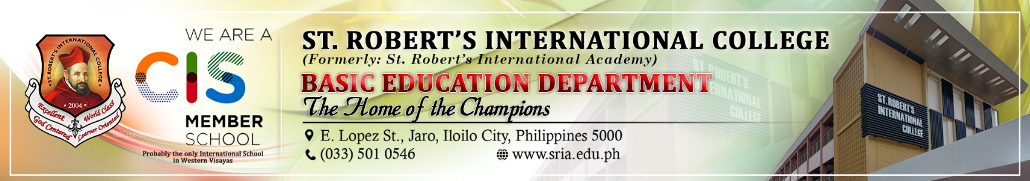
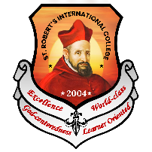

1. Program Title: Esteban S. Madrona Governance Day
1.1. Lead implementer: Lifelong Learning Department – OHS Romblon
1.2. Collaborators: Digital and Marketing Department – PR & Conventional Marketing
Research and Publications Department
SPS Department – Guidance and Counseling

2. Goals
2.1 Esteban S. Madrona Governance Day Celebration & Socialization Activities: To celebrate governance excellence, inspire leadership, and strengthen social connections through meaningful activities.
2.2. Thanksgiving Mass: To bring the community together in gratitude, spiritual reflection, and the reaffirmation of shared values and blessings.
2.3. Research Fiesta: To foster a culture of inquiry, collaboration, and innovation by showcasing research outputs and their practical applications.
2.4. Career Guidance and Counseling: To empower students to make informed career decisions by providing awareness, boosting confidence, and connecting them with mentors and opportunities.
2.5. Community Engagement – Tree Planting Activity: To promote environmental awareness and biodiversity while fostering community involvement and long-term ecological responsibility.
2.6. Marketing: To increase awareness, engagement, and participation by effectively promoting the organization's programs and building a strong, reputable brand.
3. Rationale
The Esteban S. Madrona Governance Day is a celebration of governance excellence and leadership, spearheaded by the Lifelong Learning Department – OHS Romblon, in collaboration with various institutional departments. This program aims to inspire leadership, foster innovation, and strengthen community bonds through diverse and meaningful activities. Highlights include socialization activities to promote camaraderie, a Thanksgiving Mass for spiritual reflection and gratitude, and a Research Fiesta showcasing inquiry and innovation. Career guidance sessions empower students to make informed decisions, while a tree planting activity fosters environmental awareness and community engagement. By integrating these initiatives with a strong marketing campaign, the event not only reinforces shared values but also amplifies the institution's commitment to holistic education, social responsibility, and sustainable development.
3.1. SWOT
Strengths | Weaknesses | Opportunities | Threats
Holistic Approach: Integrates leadership, education, community engagement, and sustainability. | Resource-Intensive: Requires significant manpower, funding, and coordination. | Networking Potential: Encourages connections among students, faculty, and external stakeholders. | Logistical Risks: Weather or unforeseen issues may disrupt outdoor activities.
Collaborative Effort: Multiple departments contribute expertise and resources. | Participation Challenges: Ensuring full engagement from all stakeholders can be difficult. | Institutional Recognition: Successful execution enhances the organization’s reputation. | Budget Constraints: Limited resources could reduce the quality or scale of the event.
Community Impact: Activities address personal development and societal needs, such as innovation and environmental stewardship. | Time Constraints: Diverse activities may lead to scheduling conflicts or insufficient preparation. | Sustainability Advocacy: Promotes environmental awareness and positions the institution as a leader in ecological initiatives. | Competing Priorities: Other commitments may reduce stakeholder participation or interest.

4. Objectives
4.1. To promote governance excellence and leadership by providing activities that inspire innovation, collaboration, and personal growth among participants.

4.2. To foster community engagement and shared values through inclusive events such as a Thanksgiving Mass, socialization activities, and environmental initiatives like tree planting.

4.3. To empower students with knowledge and opportunities by offering career guidance sessions and showcasing innovative research that supports informed decision-making and practical applications.

5. Target Clients
5.1. Students and Enrollees: Gain leadership skills, career guidance, research opportunities, environmental awareness, and marketing exposure for their achievements.

5.2. Faculty and Staff: Strengthen professional growth, community connections, contribute to research and innovation, and enhance their visibility through marketing efforts.

5.3. Community Members: Engage in spiritual reflection, environmental initiatives, and strengthen ties with the institution, while benefiting from marketing that promotes community involvement.

5.4. Parents and Mentors: Support career development, community engagement, holistic education, and gain insight into the institution's programs through effective marketing.

5.5. Researchers and Innovators: Showcase research, foster collaboration, and inspire innovation within the community, gaining recognition through marketing efforts.

5.6. External Stakeholders: Build partnerships, enhance understanding of the institution’s mission, and engage in leadership and sustainability efforts, all while benefiting from marketing exposure.

6. Action Plan Matrix/Schedule of Activities
DATE | ACTIVITY
March 3, 2025 | Travel from Iloilo - Romblon
March 4, 2025 | Research Fiesta – RNIT, Alcantara, Romblon
March 5, 2025 | Career Guidance and Counselling - Looc, Romblon  Community Engagement – Tree Planting Activity – Looc, Romblon
March 6, 2025 | Marketing
March 7, 2025 | Marketing
March 8, 2025 | Thanksgiving Mass – Looc, Romblon  ESM Governance Day Celebration & Socialization Activities
March 9, 2025 | Travel from Romblon - Iloilo

7. Implementation & Evaluation
7.1. Budget and Sources of Funds: This activity will request funds from the school. Attached is the budget plan.

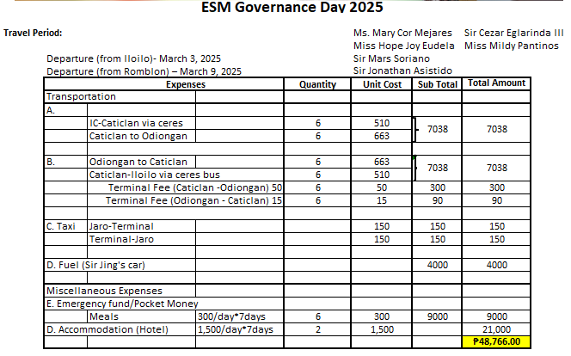

7.2. Key Performance Indicator:
7.2.1. 100% of students and parents are present.
7.2.2. At least 80% of attendees’ coherence and engagement level of the presentation or
discussion.
7.2.3. At least 70% of attendees making at least one new connection or exchanging contact
information.
7.2.4. An average rating of 4 out of 5 positive feedbacks from peers and mentors on the
solution’s innovation and applicability.
7.2.5. Satisfaction score of 4.5 out of 5 for overall event effectiveness.
.

Prepared by:

MS. MARY COR R. MEJARES
OHS Romblon – Campus Coordinator

Reviewed by:

MS. RAGELLE ESTAPON
Vice Headmaster, IBP Philippines
Asst. Principal, SHS

MR. CRIS BENGTSSON
Headmaster, International Program
Asst. Principal, Instructional Leadership

MS. MARIA TERESA BALOGO
Quality Assurance Manager

Noted by:

MS. ELNA F. GERASOL
Principal, Basic Education Department

MS. MA. HOPE JOY L. EUDELA
Institutional Director, Academic Services

MS. ANNA MARIE T. LUNO
Institutional Director, Administrative Services

MS. FAITH G. APORTADERA
Institutional Director, Student Support Services

MR. ART JAYSON L. OSUYOS
Institutional Director, Digital & Marketing Services

Recommending Approval:

MS. JENA P. BASCO
OIC Vice President, Instructional Leadership

DR. JOHN TREVOR A. GALINDEZ
Executive Vice President/ COO

Approved:

DR. ROBERT F. GALINDEZ
President/ CAO

